Modified half-normal distribution

Intro

A special case with PDF (see below figure and its description) of half-normal disribution.



Figure 1.1

Source from See Also section in Truncated normal distribution in Wiki.

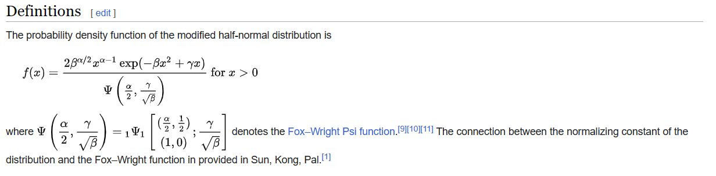

Figure 1.2

Source from Definition section in Modified half-normal distribution in Wiki.

Def

Annotation

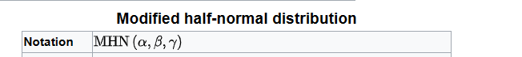

Parameter



Support



PDF

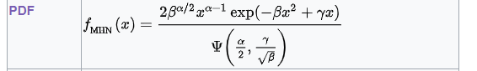

CDF

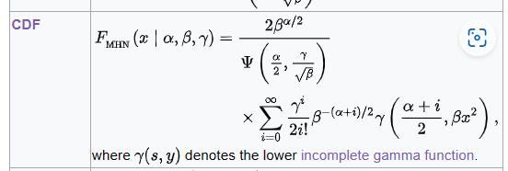

Expected Value

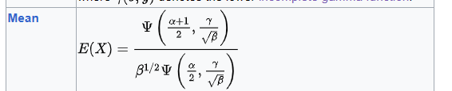

Variance

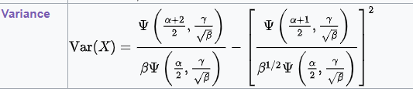

Mode



Ref

[Modified half-normal distribution - Wikipedia](https://en.wikipedia.org/wiki/Modified_half-normal_distribution)